No. 50/2023

Joint press release on Thailand as the host of the 2026 IMF-WBG Annual Meetings (AM2026) and the launch of the logo design contest
Mr. Pornchai Thiraveja, Director General of the Fiscal Policy Office, Ministry of Finance, and Ms. Chayawadee Chai-Anant, Assistant Governor Corporate Relations Group, the Bank of Thailand, held a joint press conference on Thailand as the host for 2026
IMF-WBG Annual Meetings as well as the launch of logo design contest for the Meetings.
Mr. Pornchai Thiraveja stated that “On 15 October 2023, Ministry of Finance and the Bank of Thailand (BOT) together with the International Monetary Fund (IMF) and the World Bank Group (WBG) signed the Memorandum of Understanding for Thailand as the host of the 2026 Annual Meetings of the Boards of Governors of the International Monetary Fund and the World Bank. This will be the second occasion since 1991 that Thailand has the honor to host the IMF-WBG Annual Meetings, one of the world’s top economic conferences with more than 12,000 expected attendants, including finance ministers and central bank governors of the 190 member countries.”
Ms. Chayawadee Chai-Anant stated that “The Annual Meetings will present the opportunity to exchange views on global economy and finance as well as discuss the most pressing concerns of policymakers. The Meetings are expected to spur not only economic and tourism-related activities, but also provide opportunities for trade and investment over the long run. It will also serve as a platform to showcase Thailand’s distinctive arts, culture, and cuisine to the world.”
On this special occasion, Ministry of Finance and the BOT are therefore launching the design contest for the 2026 Annual Meetings’ logo and key visuals, inviting participation and entries from the general public. The design, which will be used in all branding initiatives, souvenirs, as well as decorations, should reflect the modern vision of leadership and international cooperation, while highlighting Thailand’s unique identity. The contest is open for submission from today until 14 January 2024. For detailed rules of the contest, please visit Ministry of Finance and the Bank of Thailand websites and social media.
Ministry of Finance and the BOT would like to invite everyone to take part in hosting the Meetings. We encourage you to extend a warm welcome to the participants, leaving them an impression that inspires them to revisit Thailand.

Bank of Thailand
28 November 2023

For more information: contact Communications Department
Tel.: +66 (0) 2283 5362
E-mail: imfwblogocontest@bot.or.th

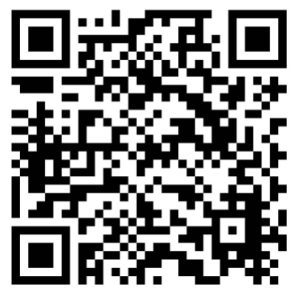
Scan QR code for the detail of logo contest

