

EXIM Thailand Collaborates with Partners
to Introduce “Green Development Model, ” Addressing Drought,
Tackling Household Debt, Boosting Agricultural Product Value,
and Fostering Sustainable Income in Huai Nam Phia, Nan
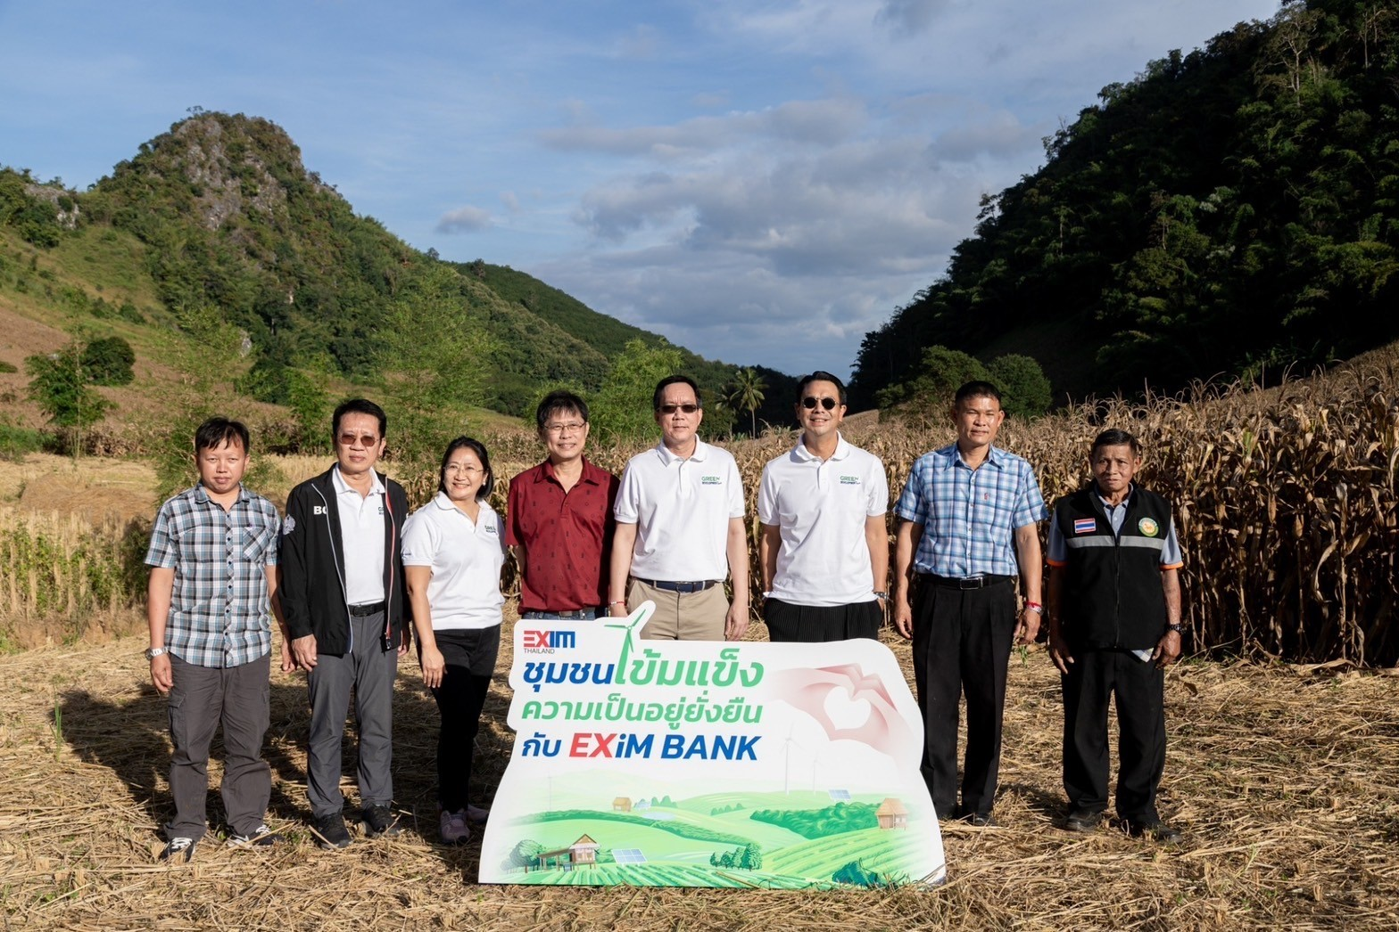

Dr. Warotai Kosolpisitkul, Chairman of the Corporate Governance and Social Responsibility (CG & CSR) Committee, Export-Import Bank of Thailand (EXIM Thailand); Mr. Suwat Kamolpanus, Chairman of EXIM Thailand’s Board of Executive Directors; Mr. Anusorn Aimkamon, Member of EXIM Thailand’s CG & CSR Committee; and Dr. Rak Vorrakitpokatorn, EXIM Thailand’s President, recently led the Bank’s executives and employees to visit the Huai Nam Phia community, located in Chetawan Village, Santa Sub-district, Na Noi District, Nan Province. Solar cell panels were installed under the collaboration between EXIM Thailand, its clients, and the Faculty of Engineering, Chulalongkorn University, led by Assoc. Prof. Sanphet Chunitipaisan, Ph.D., Associate Dean, with an aim of generating electricity for high-lift water pumping, supporting year-round agriculture. Mr. Luetha Thachai, Sub-district Chief of Santa, and Mr. Aekkachai Kangkham, Senior Deputy District Chief of Na Noi, welcomed and participated in the tree planting activity during the EXIM Thailand’s CSR event “Resilient Community, Sustainable Living,” which also included releasing fish into water sources to assist local communities with food and income.
/2

The Huai Nam Phia community has been experiencing prolonged severe drought, allowing farmers to cultivate crops only once a year, resulting in low-priced yields. The soil has deteriorated due to the use of herbicides, insecticides, and the burning of cornstalks over an extended period. Agricultural communities face challenges as farmers encroach on forest areas to relocate cultivation zones. In response, EXIM Thailand in collaboration with its clients, namely, Super Energy Corporation Public Company Limited and Eastern Power Group Public Company Limited, along with the Faculty of Engineering, Chulalongkorn University, installed solar cell panels for electricity generation for high-lift water pumping in agriculture. This initiative marks the success of EXIM Thailand in applying the “Green Development Model” to provide sustainable well-being to the local population, aligning with EXIM Thailand’s aim to become the Green Development Bank. This aims to help the community to have access to both electricity and water for year-round consumption and agriculture, reducing the impact of drought and deforestation. Moreover, it addresses environmental issues arising from soil degradation and pollution, creating opportunities for increased community income. This comprehensive and sustainable approach tackles economic, social, and environmental challenges in the community. Farmers can now cultivate perennial and fruit-bearing trees such as durian, cocoa, avocado, and date palms for consumption, significantly increasing household income, and generating higher-value produce compared to traditional crops.
Additionally, EXIM Thailand opened the “EXIM Clinic for Little People” to offer financial advice, covering savings, debt management, and income enhancement through innovative agricultural practices. This aimed to reduce household debt, alleviate poverty, and empower vulnerable groups, especially women returning to agriculture. The initiative promotes the return of people to their homeland, enhancing community bonds and creating opportunities for income generation.

November 20, 2023

For further information, please contact Corporate Branding and Communication Department
Tel. 0 2169 9999 ext. 4110-4

