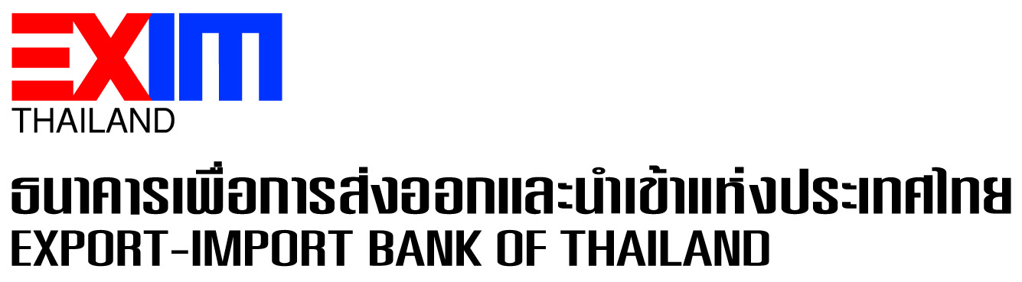

**EXIM Thailand Receives “Best Practice” Award for Its Compliance with PDPA**

Export-Import Bank of Thailand (EXIM Thailand) has received recognition as a “Best Practice” organization that has excellent implementation of personal data protection act (PDPA). This acknowledgment comes through its active participation in the Government Platform for PDPA Compliance (GPPC) initiative, a collaborative effort led by the Office of the National Digital Economy and Society Commission, Ministry of Digital Economy and Society, in conjunction with the Office of the Personal Data Protection Committee (PDPC). This achievement underscores EXIM Thailand’s unwavering commitment to ethical and responsible business practices, operating within the legal framework, emphasizing human rights, fair marketing, and ensuring the security of diverse range of customers, business counterparts, partners, and other stakeholders in all groups.

October 2, 2023

Corporate Branding and Communication Department

**For further information, please contact Corporate Branding and Communication Department**

**Tel. 0 2169 9999 ext. 4110-4**