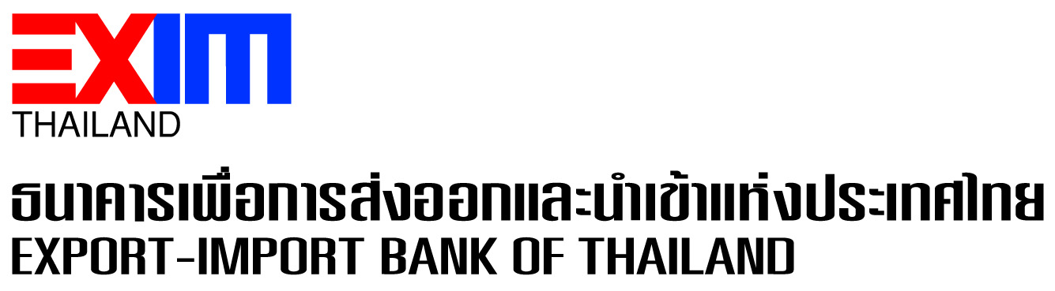

EXIM Thailand Organizes EXIM Stakeholders Day
to Brainstorm Alliances’ Viewpoints toward Sustainable Development

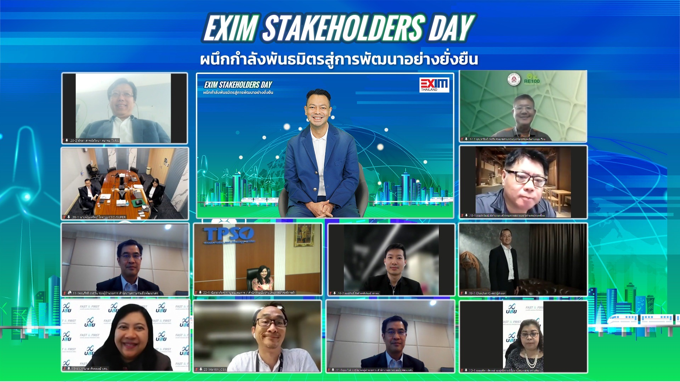

Dr. Rak Vorrakitpokatorn, President of Export-Import Bank of Thailand (EXIM Thailand), held EXIM Stakeholders Day event for the third straight year under the theme “Synergizing Alliances toward Sustainable Development” for stakeholders from all sectors to voice their opinions on the business operation direction and policies of EXIM Thailand as a specialized financial institution under the supervision of the Ministry of Finance committed to the role of “Green Development Bank.” The event was held online at EXIM Thailand’s Head Office on August 9, 2023 and participated by more than 100 representatives from regulatory agencies, shareholders, representatives from all ministries overseeing the country’s economic affairs, and those from alliance agencies in both public and private sectors, such as Federation of Thai Industries, Thai Chamber of Commerce and Board of Trade of Thailand, Thai National Shippers’ Council, financial institutions and customers of all scales.
All feedback and viewpoints from the EXIM Shareholders Day event will be taken into account in EXIM Thailand’s formulation and mapping of its business direction, policies and plans, as well as guidelines for the organization development toward the goal of sustainable development and socially and environmentally responsible banking. This would align with the current circumstances and relevant surrounding factors in response to demands and expectations of stakeholders in all sectors. The Bank also aims to support Thai SMEs for their sustainable competition on the global front, create value added, and propel Thailand’s international trade and investment including penetration of new frontiers that have high potential alongside encouraging Thai business sectors to operate their businesses with environmental, social and governance (ESG) concerns in the joint efforts to drive sustainable development of Thailand and the global community.
August 9, 2023
For further information, please contact Corporate Branding and Communication Department
Tel. 0 2169 9999 ext. 4110-4

