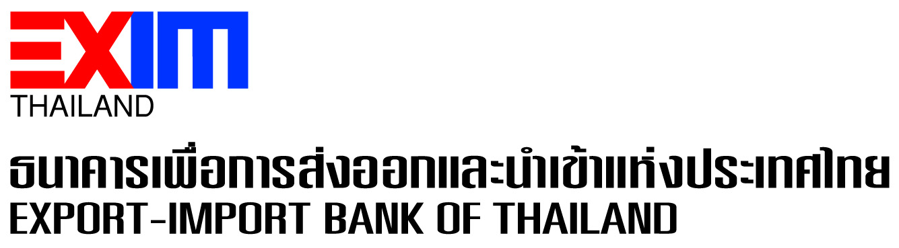

EXIM Thailand Wins Best Bond Awards 2022 from ThaiBMA

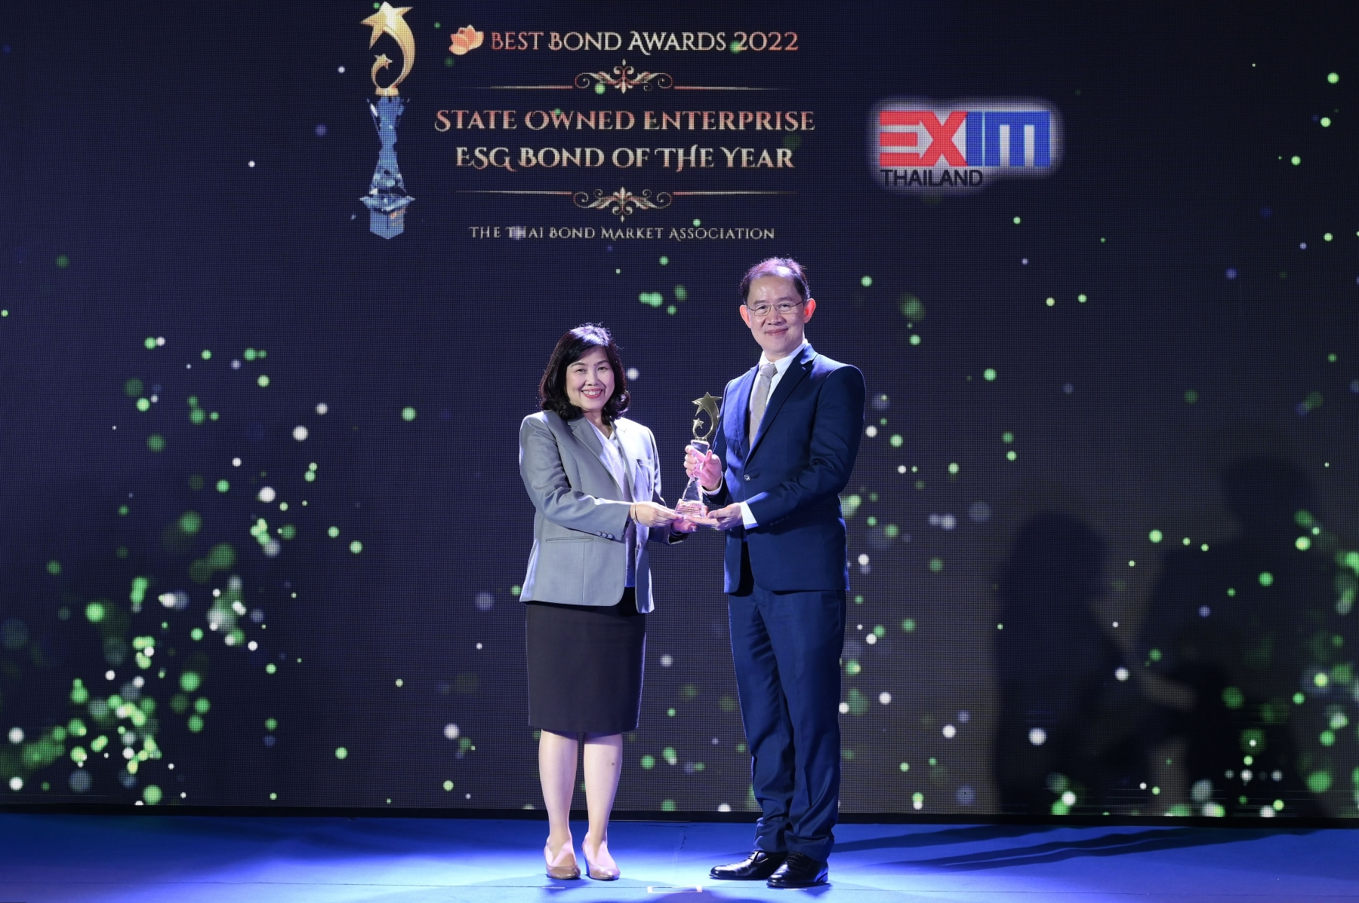

Mrs. Wanpen Unchundacha, Executive Vice President, Export-Import Bank of Thailand (EXIM Thailand), received the State Owned Enterprise ESG Bond of the Year Award from Dr. Somjin Sornpaisarn, President of The Thai Bond Market Association (ThaiBMA), at the ThaiBMA Best Bond Awards 2022 presentation ceremony organized by ThaiBMA in recognition of organizations and personalities with outstanding achievements in debt instrument transactions in 2022 at Park Hyatt Bangkok Hotel, on March 15, 2023, for EXIM Thailand’s successful issue and offering of 5-billion baht dual-tranche Green Bond in September 2022 to raise funds for lending to clean energy projects. The Green Bond was well responded by leading investors and carried attractive coupon rates amid the volatile money market conditions and the upward trend of interest rates.

In 2022, EXIM Thailand issued 2 tranches of Green Bond with Asian Development Bank (ADB) as the Bond Advisor working out the Sustainable Finance Framework, Government Savings Bank as the Underwriter, and Bank of Ayudhya as the Underwriter and Registrar. The Bank is committed to operating its business according to its responsible finance management and sustainable development policies. It has planned to consistently raise funds under the Sustainable Finance Framework as part of its determination to drive green economy in line with the United Nations Sustainable Development Goals (SDGs) guideline and the declaration jointly made by Thai government at the 26th UN Climate Change Conference (COP 26) targeting to achieve net-zero emissions by 2065.

March 16, 2023

For further information, please contact Corporate Branding and Communication Department
Tel. 0 2271 3700, 0 2278 0047, 0 2617 2111 ext. 4110-4

