

EXIM Thailand Joins Hands with EGAT
in Supporting Refrigeration Industry to Help Reduce Energy Consumption
and Greenhouse Gases Emission Reduction of Thai Industries
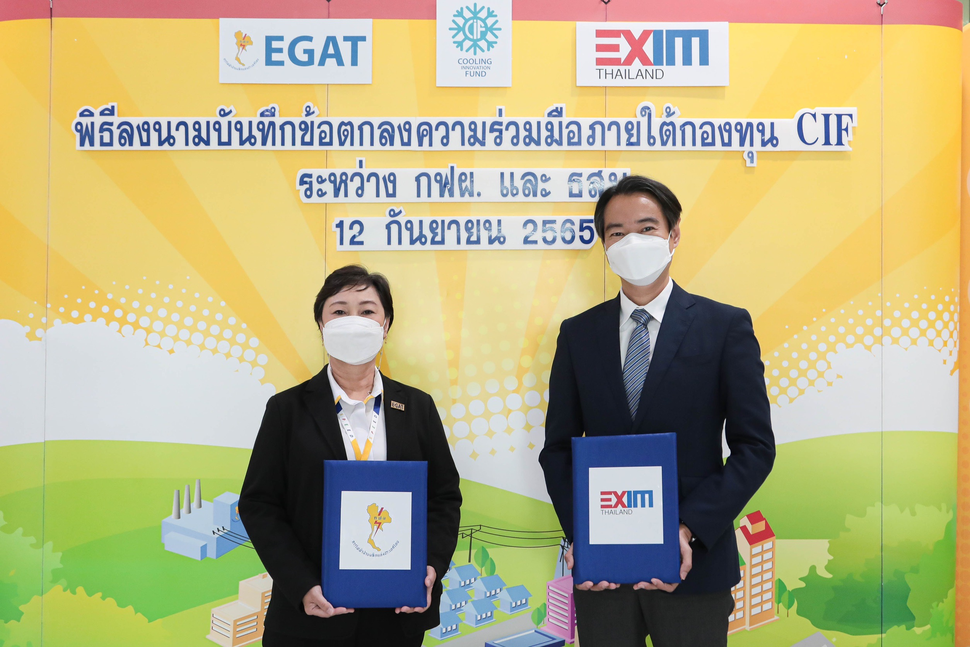

Mr. Ittipol Lertsakthanakul (right), Executive Vice President of Export-Import Bank of Thailand (EXIM Thailand), and Mrs. Sriwan Buranachokepisal (left), Assistant Governor, Power Plant Planning of Electricity Generating Authority of Thailand (EGAT) and Chairman of EGAT Cooling Innovation Fund (CIF) Committee, jointly signed a Memorandum of Understanding (MOU) for cooperation on “Promotion and Enhancement of Thailand’s Green Cooling under EGAT Cooling Innovation Fund (CIF)” at EGAT Headquarter, Nonthaburi Province, on September 12, 2022. Under the MOU, EXIM Thailand and EGAT aim to encourage Thai entrepreneurs’ operations of businesses supportive of lessened energy consumption, such as using natural cooling agents that are eco-friendly, related to energy efficiency and conducive to reduction of greenhouse gases emissions and knowledge exchange.

EXIM Thailand is a state-owned specialized financial institution aiming to take the role of Thailand Development Bank to support building of new industries that drive Bio-Circular-Green (BCG) economy and enhance energy security in ASEAN alongside balancing social, environmental and economic growth on a sustainable basis. The cooperation between EXIM Thailand and EGAT aims to drive and support projects that enhance energy consumption efficiency and reduce emissions of greenhouse gases in air-conditioning and refrigeration industries through the CIF under collaboration between EGAT and German Agency for International Cooperation (GIZ). EGAT will support important knowledge and technical aspect about change and use of natural refrigerant technology which have good efficiency, reduce electricity consumption, the Ozone Depletion Potential (ODP) Index and Global Warming Potential (GWP) Index. EXIM Thailand also offers financial facilities, one of which is EXIM Kill Bill by Biz Transformation for entrepreneurs’ replacement of chillers and use of energy saving equipment, at the minimum interest rate of 2.00% per annum and a maximum loan tenor up to 7 years. These measures of EXIM Thailand and EGAT will contribute to Thailand’s achievement of its net zero emission goal.

September 12, 2022

For further information, please contact Corporate Branding and Communication Department
Tel. 0 2271 3700, 0 2278 0047, 0 2617 2111 ext. 4120-4

