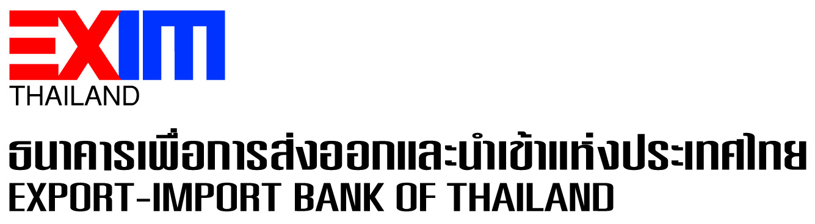

**EXIM Thailand Joins Forces with KBank and BBL to Finance B.Grimm Power Group’s First Expansion of Solar Power Plant Business to Cambodia**

**EXIM Thailand has collaborated with KBank and BBL in rendering a syndicated loan of 900 million baht to B.Grimm Power Plc. Group for its investment in development of a 39 MW solar power plant in Banteay Meanchey Province of Cambodia under a 20-year power purchase agreement with Electricity Authority of Cambodia aiming to promote trade and investment associated with sustainable development goals.**

Dr. Rak Vorrakitpokatorn, President of Export-Import Bank of Thailand (EXIM Thailand), jointly with Mr. Tipakorn Saiphatana, Executive Vice President of Kasikornbank Plc. (KBank), Miss Niramarn Laisathit, Senior Executive Vice President of Bangkok Bank Plc. (BBL), and Dr. Harald Link, Chairman and President of B.Grimm Power Plc., recently signed a syndicated loan agreement to finance investment of Ray Power Supply Co., Ltd., a company under B.Grimm Power Group, in development of a solar power plant with a generating capacity of 39 MW in Si Sophon City, Banteay Meanchey Province of Cambodia. The power generation is under a power purchase agreement with Electricite Du Cambodge (EDC), which is the Electricity Authority of Cambodia, on a 20-year contractual basis and commercial operation date (COD) of which has been achieved since December 2020.

EXIM Thailand President said that EXIM Thailand’s participation in this syndicated financing is aimed at enabling Thai investors with high potential to expand their investment beyond Thailand to a greater extent. This would be in line with EXIM Thailand’s policy to move toward being Thailand Development Bank, driving and linking Thailand’s international trade with and investment in counterpart countries. B.Grimm Power Group is a Thai investor with dependable expertise and experience in power plant business operations both domestically and overseas, e.g. Lao PDR and Vietnam. It would be their first time to expand its power plant investment to Cambodia to serve this country’s industrial, trade and investment growth and urbanization of Si Sophon City in Banteay Meanchey Province, as well as the increasing demand for electricity in line with Cambodia’s continued economic expansion in linkage with its neighboring countries in ASEAN.

“EXIM Thailand has remained steadfast in its mandated commitment to the role of Thailand Development Bank to operate business under corporate governance principles and with social responsibility as well as responsible financial management, aiming to promote trade and investment conducive to sustainable development at the national, regional and global levels. We have thus consistently developed our financial facilities and expanded cooperation with public and private sectors in supporting and incubation of businesses that would bring about positive impacts in economic, social and environmental dimensions. This would keep our country on track to achieve sustainable development goals thereby all countries must lend their helping hands to build a better world with higher quality of life of peoples in the long run,” added Dr. Rak.

November 4, 2021

Sustainable Development and Corporate Communication Department

**For further information, please contact Sustainable Development and Corporate Communication Department**

**Tel. 0 2271 3700, 0 2278 0047, 0 2617 2111 ext. 4120-4**