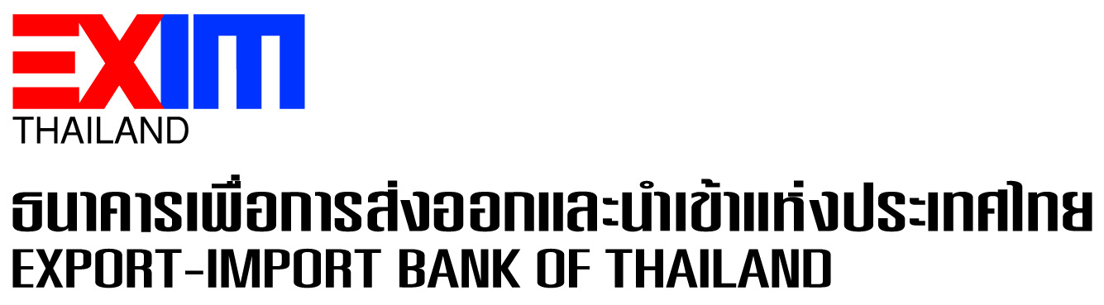

**EXIM Thailand Supports Mermaid Maritime Group,**

**Subsea Engineering Service Provider, in Penetrating Middle East Market with Financial Liquidity Enhancement for Sustainable Business Growth**

**EXIM Thailand has rendered financial support in the amount of 100 million baht to Mermaid Maritime Public Company Limited in the Group of Thoresen Thai Agencies Public Company Limited to boost liquidity for its subsea and offshore engineering services, which is in line with EXIM Thailand’s mission to restructure Thai industries with high value added and strengthen competitiveness of Thai entrepreneurs in the global market.**

Dr. Rak Vorrakitpokatorn, President of Export-Import Bank of Thailand (EXIM Thailand), and Mr. Chalermchai Mahagitsiri, President and Chief Executive Officer of Thoresen Thai Agencies Public Company Limited (TTA), jointly signed a credit facility agreement worth 100 million baht at EXIM Thailand’s Head Office on September 16, 2021 to enhance liquidity for Mermaid Maritime Public Company Limited (Mermaid), a member of TTA Group and provider of subsea and offshore engineering services for more than 30 years, to be well positioned to reach out to the Middle East market.

EXIM Thailand President further said that EXIM Thailand has extended financial support to Mermaid under the “Global Oonjai Credit (Heart-warming GlobalCredit)” scheme, a long-term credit facility with a 5-year maximum tenor for the company’s use as working capital in providing services overseas, particularly the Middle East countries, on a consistent basis. Mermaid Group is the only Thai entrepreneur acceptable to world leading oil and gas companies, those in the Middle East in particular. The credit facility will be used for managing a fleet of 3 ships to support Mermaid Group’s offshore operations for the complex and challenging subsea engineering at all levels in various sites around the world. It will also support Thai oil and gas industry hit by oil price fluctuations amid the COVID-19 pandemic.

“EXIM Thailand’s financial support aims to enhance Thai entrepreneurs’ competitiveness with the adoption of technology and innovation to improve the operation related to provision of maritime services and penetration of new frontiers to a greater extent. This is in line with our mission to reboot, rebuild and rebalance Thai entrepreneurs at all levels in the industrial sectors in response to goods and services demand of business sectors and consumers today and beyond,” added Dr. Rak.

September 16, 2021

Sustainable Development and Corporate Communication Department

**For further information, please contact Sustainable Development and Corporate Communication Department**

### **Tel. 0 2271 3700, 0 2278 0047, 0 2617 2111 ext. 4120-4**