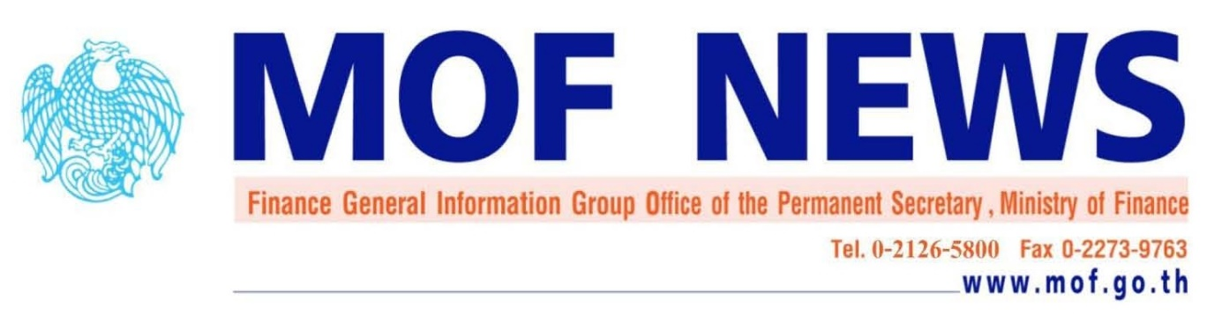
Public Debt Management Office, Rama 6 Rd. Phayathai, Bangkok, THAILAND 10400 Tel. +66 (0)22658050

No. 109 /2017 August 29, 2017
Public Debt Outstanding Report as of August31, 2017
Mr. Theeraj Athanavanich,Bond Market Advisor,reported that Thailand’s public debt outstanding as of August31, 2017 was at 6,274,872.04million Baht (41.92% of GDP).The total public debt outstanding comprised 4,861,262.73million Baht of Government debt, 966,596.76million Baht of State-Owned Enterprises (SOEs) debt, 432,369.05million Bahtof Government Guaranteed Financial SOEs debt and 14,643.50million Baht of Other Government Agencies debt. Compared with last month, public debt outstandingincreased by 49,883.29 million Bahtwith details as follows:
- Government debt outstanding was at 4,861,262.73million Baht, increasing by 57,718.76million Baht.The detail of change in government debt asthe followings:
- Financing under the Annual Budget Expenditure Act B.E. 2560 (A.D. 2017),supplementary budget and debt managementincreased by36,000 million Bahtfor the country development, strengthening communities and grass roots economy and enhancing competitiveness.
- Domestic debt to finance infrastructure investmentincreased by 1,884million Bahtwhich resulted from(1) an increase in On-lending debt by 1,049.73million Baht to Mass Rapid Transit Authority of Thailand for theGreenLine,Blue Line,Orange Line and Purple LineProjects.(2) an increase in On-lending debt by 808.43 million Baht to State Railway of Thailand for Double-track Jira Road-Khonkaen Project, Double-track Chachoengsao-Klong 19-Kaeng Koi Projectand Red Line Mass Transit System Project and (3) an increase in On-lending debt by 25.84 million Baht to National Housing Authority for the Phase G Residential Building and Facilities for Dindaeng Urban Renewal Project.
- Debt repayments under the Emergency Decree authorizing the MOF to Secure Loans for Financial Institutions Development Fundwere made in an amount of 1,188.46million Baht.
- External debtincreased by171.22million Baht mainly due to the disbursement and debt repayment and changes in foreign exchange rates.
- State-Owned Enterprise debtwas at 966,596.76million Baht, decreasing by1,061.56million Baht. This change was mainly contributed from the followings:
- Government Guaranteed debtincreased by1,210.96 million Baht. This was mainly from the issuing and redeeming bond and debt repayment of the State Railway of Thailand.
- Non-Government Guaranteed debt decreased by 2,272.52million Baht. This wassignificantly fromthe debt repayment of the Thai Airways International Public Co., Ltd.
- Financial State-Owned Enterprise debt (Government Guaranteed)was at432,369.05million Baht, decreasing by 5,902.62million Baht. This change was mainly resulted from the debt repayment by the Bank for Agriculture and Agricultural Co-operatives.
- Other Government Agencies debtwas at14,643.50million Baht, decreasing by 871.29million Bahtmainly due to the debt repayment of the Office of the Cane and Sugar Fund and the disbursement of the Neighbouring Countries Economic Development Cooperation Agency.

Public debt outstanding as of August31, 2017 was at 6,274,872.04million Baht, of which,5,969,776.07million Baht was domestic debt(95.14% of total public debt), and 305,095.97million Baht(9,155.13 million USD) was external debt (4.86% of total public debt).

Classified by remaining maturity, long-term debt outstanding was5,623,790.54
million Baht (89.62% of total public debt) and short-term debt outstanding was 651,081.50million Baht(10.38% of total public debt).

Public Debt Management Office
Tel. +66 2 265 8050 Ext. 5520

