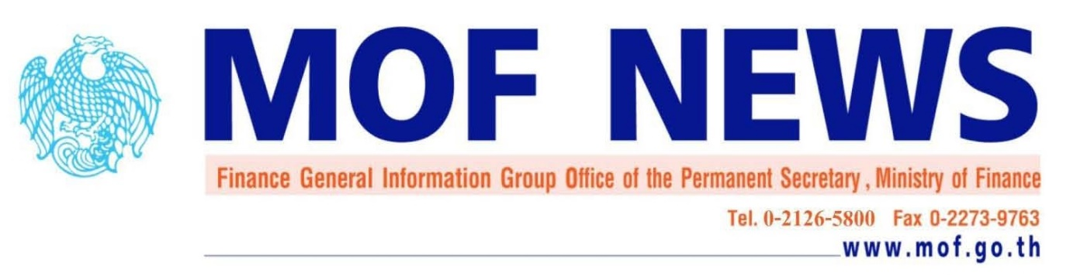
No. 100/2017 September 8, 2017

Permission to Issue Baht-denominated Bonds or Debentures by Foreign Entity
in Thailand during 1 September 2017 – 31 May 2018
_________________________________

Pursuant to the Ministry of Finance’s Ministerial Notification re: Permission to Issue Baht-denominated bonds or debentures in Thailand on 11th April 2006 and four amendments, the Ministry of Finance informs that the criteria to be considered comprise of impacts on Thai corporate bond issuance, the opportunity for domestic investors to invest in quality bond, the development of Baht-denominated bond market and the impact on Thailand’s financial market. For the issuance period during 1st September 2017 – 31st May 2018, the Minister of Finance has permitted 2 foreign entities to issue Baht-dominated bonds or debentures in Thailand within 31st May 2018 upon the agreement that the 2 foreign entities must use all proceeds from the debentures according to the terms and conditions specified by the Ministry of Finance. The lists of the permitted entities are as follows:
1. The Ministry of Finance of the Lao People’s Democratic Republic
2. Nam Ngum 2 Power Company
The Ministry of Finance, thereby, reserves the right to restrain any Baht-denominated bond or debenture issuance if there appears to be significant changes in the financial status or structure of the permitted entities or the permitted entities fail to perform according to the conditions stated in the approval letter.
The Ministry of Finance is pleased to inform that there will be a special supplementary submission during the 6th September – 6th October 2017 for permission to issue Baht-dominated bonds or debentures, with tenor not longer than 3 years, from the 1st November 2017 to 31st March 2018. The issuers will be allowed to use the proceeds in the followings; 1) domestic transaction in Baht and 2) onshore USD/THB spot exchange.
The Ministry of Finance extends its sincere appreciation to all applicants for their interests in Baht-denominated bonds in the Thai bond market. For the next submission periods, qualified entities who may be interested in issuing Baht-dominated bonds or debentures are able to submit their applications three times a year in March, July and November.
__________________________________________

Bond Market Development Bureau, Public Debt Management Office Tel: 02-2717999 #5809

